**Course Curriculum**

**Intro:** What is Data Science? Course FAQ. Course Best practices, getting help, end installation.   
**R Basics:** Vectors, Matrices, Data Frames, Lists   
**Data Input and Output:** CSV, Excel, SQL, Web Scraping  
**Programming with R:** Logical operators, if, else if, looks, and function creation.   
**Data Visualization:** Static and Interactive visualizations with ggplot2  
**Capstone Projects:** On data visualization and data   
**Machine Learning:** ML will take the second half of the course

**What is Data Science**  
- Growing Interest in DS as a Field

* Why the explosion of popularity?   
  - More data available than ever before   
  - Large computing power easily available   
  - New programming tools  
  - Huge skills demand

- Growing Demand in Job Market  
- Overview of Data Science

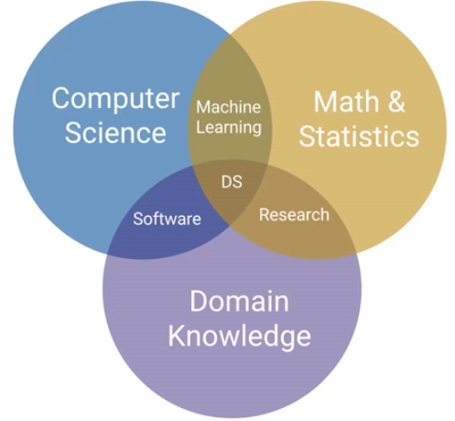

Machine Learning is only part of Data Science.  
  
**Course Recourses**Course notes are HTML files. Can convert to PDFs if needed.

RStudio Environment

You can get the working directory by looking in the “**Files**” pane.   
You can also get is from the Console, using the command: **getwd()** = prints the current working directory

You can set the working directory under **Session 🡪 Set Working Directory**   
You can also set it from the Console, using command: **setwd(‘C//…’)**  
You can also set a default working directory under: **Tools 🡪 Global Options**

To write multiple commands, you use the “**R Script”** pane, which you can start with the **“+” icon** on the top left.  
You can also create R Markdown, R Shiny web app, which we can look at later.

In the “R Script” pane, “**Run**” prints the line of code the curser is on, or the lines you have selected.  
The “Run” with the back arrow, runs the last command.   
The **“Source”**  runs the entire source script.   
  
The output comes out in the console.